**JavaScript**

**1) Two Sum**  
Given an array of integers nums and an integer target, return *indices of the two numbers such that they add up to target*.

You may assume that each input would have ***exactly* one solution**, and you may not use the *same* element twice.

You can return the answer in any order.

**Example 1:**

**Input:** nums = [2,7,11,15], target = 9

**Output:** [0,1]

**Explanation:** Because nums[0] + nums[1] == 9, we return [0, 1].

**Example 2:**

**Input:** nums = [3,2,4], target = 6

**Output:** [1,2]

**Example 3:**

**Input:** nums = [3,3], target = 6

**Output:** [0,1]

**2) Palindrome Number**  
Given an integer x, return true if x is palindrome integer.

An integer is a **palindrome** when it reads the same backward as forward.

* For example, 121 is a palindrome while 123 is not.

**Example 1:**

**Input:** x = 121

**Output:** true

**Explanation:** 121 reads as 121 from left to right and from right to left.

**Example 2:**

**Input:** x = -121

**Output:** false

**Explanation:** From left to right, it reads -121. From right to left, it becomes 121-. Therefore it is not a palindrome.

**Example 3:**

**Input:** x = 10

**Output:** false

**Explanation:** Reads 01 from right to left. Therefore it is not a palindrome.

**3) Longest Common Prefix**

Write a function to find the longest common prefix string amongst an array of strings.

If there is no common prefix, return an empty string "".

**Example 1:**

**Input:** strs = ["flower","flow","flight"]

**Output:** "fl"

**Example 2:**

**Input:** strs = ["dog","racecar","car"]

**Output:** ""

**Explanation:** There is no common prefix among the input strings.

**4)  Remove Duplicates from Sorted Array**

Given an integer array nums sorted in **non-decreasing order**, remove the duplicates [**in-place**](https://en.wikipedia.org/wiki/In-place_algorithm) such that each unique element appears only **once**. The **relative order** of the elements should be kept the **same**.

Since it is impossible to change the length of the array in some languages, you must instead have the result be placed in the **first part** of the array nums. More formally, if there are k elements after removing the duplicates, then the first k elements of nums should hold the final result. It does not matter what you leave beyond the first k elements.

Return k after placing the final result in the first k slots of nums.

Do **not** allocate extra space for another array. You must do this by **modifying the input array**[**in-place**](https://en.wikipedia.org/wiki/In-place_algorithm) with O(1) extra memory.

**Custom Judge:**

The judge will test your solution with the following code:

int[] nums = [...]; // Input array

int[] expectedNums = [...]; // The expected answer with correct length

int k = removeDuplicates(nums); // Calls your implementation

assert k == expectedNums.length;

for (int i = 0; i < k; i++) {

assert nums[i] == expectedNums[i];

}

If all assertions pass, then your solution will be **accepted**.

**Example 1:**

**Input:** nums = [1,1,2]

**Output:** 2, nums = [1,2,_]

**Explanation:** Your function should return k = 2, with the first two elements of nums being 1 and 2 respectively.

It does not matter what you leave beyond the returned k (hence they are underscores).

**Example 2:**

**Input:** nums = [0,0,1,1,1,2,2,3,3,4]

**Output:** 5, nums = [0,1,2,3,4,_,_,_,_,_]

**Explanation:** Your function should return k = 5, with the first five elements of nums being 0, 1, 2, 3, and 4 respectively.

It does not matter what you leave beyond the returned k (hence they are underscores).

**Html & CSS**

How do you turn a html element into a flex container?

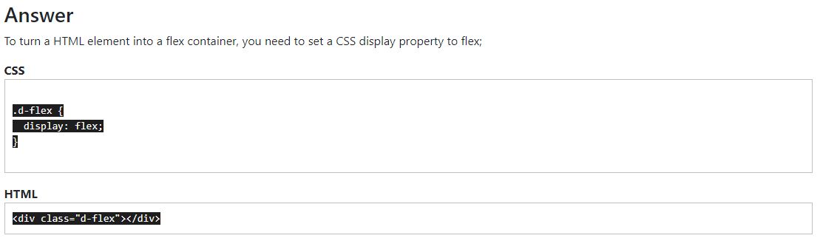

**What does justify-content CSS property do and what values can it have?**

